The board also supports Ethernet connection

Commands:

1. ifconfig(similar to ipconfig in windows………………. Rpi also supports ifconfig)
2. ifup eth0

changes made in the code:

1. change the mac address to byte mac[] = { 0x98, 0x4F, 0xEE, 0x05, 0x38, 0x01 };
2. this is the mac address of my intel Galileo Ethernet shield
3. add system("ifup eth0");
4. and add
5. IPAddress my=Ethernet.localIP();
6. Serial.println(my);
7. This gives ip address of my board
8. We can ping the board using cmd prompt using the cmd: ping “……………….address in my………….”
9. Also we can create a webserver using the code in the included file and then open the ip address provided in the chrome

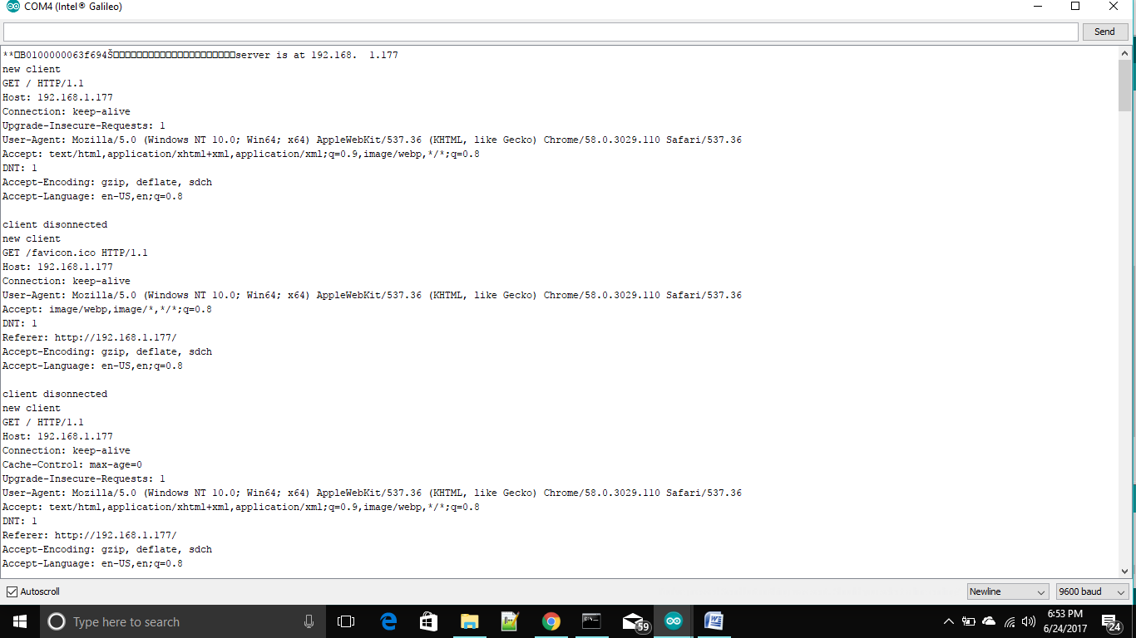

So what I observe is webclient connects to internet and does things while webserver hosts the web service

The thingSpeak that I have observed takes data from iot and stores it on cloud that means in this webclient will be used and data will be saved using url.

Thus in the same way data can be saved anywhere that is in any website that we want to create or we create using url method.